**Student report managment**

Project submitted to the

SRM University – AP, Andhra Pradesh

Submitted in partial fulfilment of the requirement for the award of the degree of

**Bachelor of Technology**

**in**

**Computer Science and Engineering**

**School of Engineering and Sciences**

Submitted By

**M Nandita**

AP21110010829

Under the guidance of

Elakkiya.E



# Department of Computer Science and Engineering

**SRM University,AP**

**Neerukonda, Mangalagiri, Guntur**

**Andhra Pradesh – 522 240 [Month, Year]**

# Department of Computer Science and Engineering

SRM University, Andhra Pradesh



**CERTIFICATE**

This is to certify that the Project report entitled **“student report managment”** is being submitted by **M Nandita(AP21110010829),** a student of Department of Computer Science and Engineering, SRM University,AP, in partial fulfilment of the requirement for the degree of **“B.Tech(CSE)”** carried out by her/his during the academic year 2021-2022.

|  |  |
| --- | --- |
| Signature of the Supervisor | Signature of Head of the Dept. |
| **Elakkiya.E** | **JATINDRA KUMAR DASH** |

# Acknowledgement

The satisfaction that accompanies the successful completion of any task would be incomplete without introducing the people who made it possible and whose constant guidance and encouragement crowns all efforts with success.

I am extremely grateful and express my profound gratitude and indebtedness to my project guide, , Mrs elakkiya.E Lecturer, Department of Computer Science & Engineering, SRM University, Andhra Pradesh, for her kind help and for giving me the necessary guidance and valuable suggest user can get weather conclusions of the place he enters

## Table of contents

Introduction

Features

Technologies used

Algorithm

Source code

Output screenshots

Conclusion

references

**Introduction**

* Using C++ programming we created a project called student report management
* We can perform different records of student using classes and objects
* We used functions files and basic input and output functions

Features:

* We can add a new record
* Modify a student record
* Delete a student record
* Display records
* Searching a record of student

Technologies Used:

Language used :C++

Compiler Used **:**DEV C++

Operating System Used:Windows

**Algorithm:**

Step 1: start

Step 2:choose the option you want that is displayed on main menu

Step 3: if sub menu is taken we can enter a student record, delete a student record, search a student record and can modify a record and can display all records it depends on our selection

Step 4: if choice is 2 in main menu we can go back to main menu

Step 5: if choice is 3 we can exist

Step 6:stop

Code:

#include<iostream>

#include<fstream>

#include<iomanip>

using namespace std;

class student

{

int rollno;

char name[50];

int physics_marks, chemistry_marks, maths_marks, economics_marks,computerscience_marks;

double per;

char grade;

void calculatemarks(); //function to calculate grade

public:

void getdetails(); //function to accept data from user

void showdetails() const; //function to show data on screen

void show_tabularform() const;

int returnrollno() const;

}; //class ends here

void student::calculatemarks()

{

{

per=(physics_marks+chemistry_marks+maths_marks+economics_marks+computerscience_marks)/5.0;

if(per>=60)

grade='A';

else if(per>=50)

grade='B';

else if(per>=33)

grade='C';

else

grade='F';

}

}

void student::getdetails()

{

cout<<"\nEnter The roll number:";

cin>>rollno;

cout<<"\n\nEnter The Name:";

cin.ignore();

cin.getline(name,50);

cout<<"\nEnter The marks in physics: ";

cin>>physics_marks;

cout<<"\nEnter The marks in chemistry: ";

cin>>chemistry_marks;

cout<<"\nEnter The marks in maths: ";

cin>>maths_marks;

cout<<"\nEnter The marks in economics: ";

cin>>economics_marks;

cout<<"\nEnter The marks in computer science: ";

cin>>computerscience_marks;

calculatemarks();

}

void student::showdetails() const

{

cout<<"\nRoll number of student : "<<rollno;

cout<<"\nName of student : "<<name;

cout<<"\nMarks in Physics : "<<physics_marks;

cout<<"\nMarks in Chemistry : "<<chemistry_marks;

cout<<"\nMarks in Maths : "<<maths_marks;

cout<<"\nMarks in English : "<<economics_marks;

cout<<"\nMarks in Computer Science :"<<computerscience_marks;

cout<<"\nPercentage of student is :"<<per;

cout<<"\nGrade of student is :"<<grade;

}

void student::show_tabularform() const

{

cout<<rollno<<setw(6)<<" "<<name<<setw(10)<<physics_marks<<setw(4)<<chemistry_marks<<setw(4)<<maths_marks<<setw(4)

<<economics_marks<<setw(4)<<computerscience_marks<<setw(8)<<per<<setw(6)<<grade<<endl;

}

int student::returnrollno() const

{

return rollno;

}

//***************************************************************

// function declaration

//****************************************************************

void write_student(); //write the record in binary file

void display_all(); //read all records from binary file

void display_sp(int); //accept rollno and read record from binary file

void modify_student(int); //accept rollno and update record of binary file

void delete_student(int); //accept rollno and delete selected records from binary file

void class_result(); //display all records in tabular format from binary file

void result(); //display result menu

void entry_menu(); //display entry menu on screen

//***************************************************************

// THE MAIN FUNCTION OF PROGRAM

//****************************************************************

int main()

{

char ch;

cout.setf(ios::fixed|ios::showpoint);

cout<<setprecision(2); // program outputs decimal number to two decimal places

do

{

system("cls");

cout<<"\n\n\n\tMAIN MENU";

cout<<"\n\n\t01. RESULT MENU";

cout<<"\n\n\t02. ENTRY/EDIT MENU";

cout<<"\n\n\t03. EXIT";

cout<<"\n\n\tPlease Select Your Option (1-3) ";

cin>>ch;

switch(ch)

{

case '1': result();

break;

case '2': entry_menu();

break;

case '3':

break;

default :cout<<"\a";

}

}while(ch!='3');

return 0;

}

//***************************************************************

// function to write in file

//****************************************************************

void write_student()

{

student st;

ofstream outFile;

outFile.open("student.dat",ios::binary|ios::app);

st.getdetails();

outFile.write(reinterpret_cast<char *> (&st), sizeof(student));

outFile.close();

cout<<"\n\nStudent record Has Been Created ";

cin.ignore();

cin.get();

}

//***************************************************************

// function to read all records from file

//****************************************************************

void display_all()

{

student st;

ifstream inFile;

inFile.open("student.dat",ios::binary);

if(!inFile)

{

cout<<"File could not be open !! Press any Key...";

cin.ignore();

cin.get();

return;

}

cout<<"\n\n\n\t\tDISPLAY ALL RECORD !!!\n\n";

while(inFile.read(reinterpret_cast<char *> (&st), sizeof(student)))

{

st.showdetails();

cout<<"\n\n====================================\n";

}

inFile.close();

cin.ignore();

cin.get();

}

//***************************************************************

// function to read specific record from file

//****************************************************************

void display_sp(int n)

{

student st;

ifstream inFile;

inFile.open("student.dat",ios::binary);

if(!inFile)

{

cout<<"File could not be open !! Press any Key...";

cin.ignore();

cin.get();

return;

}

bool flag=false;

while(inFile.read(reinterpret_cast<char *> (&st), sizeof(student)))

{

if(st.returnrollno()==n)

{

st.showdetails();

flag=true;

}

}

inFile.close();

if(flag==false)

cout<<"\n\nrecord not exist";

cin.ignore();

cin.get();

}

//***************************************************************

// function to modify record of file

//****************************************************************

void modify_student(int n)

{

bool found=false;

student st;

fstream File;

File.open("student.dat",ios::binary|ios::in|ios::out);

if(!File)

{

cout<<"File could not be open !! Press any Key...";

cin.ignore();

cin.get();

return;

}

while(!File.eof() && found==false)

{

File.read(reinterpret_cast<char *> (&st), sizeof(student));

if(st.returnrollno()==n)

{

st.showdetails();

cout<<"\n\nPlease Enter The New Details of student"<<endl;

st.getdetails();

int pos=(-1)*static_cast<int>(sizeof(st));

File.seekp(pos,ios::cur);

File.write(reinterpret_cast<char *> (&st), sizeof(student));

cout<<"\n\n\t Record Updated";

found=true;

}

}

File.close();

if(found==false)

cout<<"\n\n Record Not Found ";

cin.ignore();

cin.get();

}

//***************************************************************

// function to delete record of file

//****************************************************************

void delete_student(int n)

{

student st;

ifstream inFile;

inFile.open("student.dat",ios::binary);

if(!inFile)

{

cout<<"File could not be open !! Press any Key...";

cin.ignore();

cin.get();

return;

}

ofstream outFile;

outFile.open("Temp.dat",ios::out);

inFile.seekg(0,ios::beg);

while(inFile.read(reinterpret_cast<char *> (&st), sizeof(student)))

{

if(st.returnrollno()!=n)

{

outFile.write(reinterpret_cast<char *> (&st), sizeof(student));

}

}

outFile.close();

inFile.close();

remove("student.dat");

rename("Temp.dat","student.dat");

cout<<"\n\n\tRecord Deleted ..";

cin.ignore();

cin.get();

}

//***************************************************************

// function to display all students grade report

//****************************************************************

void class_result()

{

student st;

ifstream inFile;

inFile.open("student.dat",ios::binary);

if(!inFile)

{

cout<<"File could not be open !! Press any Key...";

cin.ignore();

cin.get();

return;

}

cout<<"\n\n\t\tALL STUDENTS RESULT \n\n";

cout<<"==========================================================\n";

cout<<"R.No Name Phyiscs Chemistry Maths Economics ComputerScience %age Grade"<<endl;

cout<<"==========================================================\n";

while(inFile.read(reinterpret_cast<char *> (&st), sizeof(student)))

{

st.show_tabularform();

}

cin.ignore();

cin.get();

inFile.close();

}

//***************************************************************

// function to display result menu

//****************************************************************

void result()

{

char ch;

int rno;

system("cls");

cout<<"\n\n\n\tRESULT MENU";

cout<<"\n\n\n\t1. Class Result";

cout<<"\n\n\t2. Student Report Card";

cout<<"\n\n\t3. Back to Main Menu";

cout<<"\n\n\n\tEnter Choice (1/2/3)? ";

cin>>ch;

system("cls");

switch(ch)

{

case '1' : class_result(); break;

case '2' : cout<<"\n\n\tEnter Roll Number Of Student : "; cin>>rno;

display_sp(rno); break;

case '3' : break;

default: cout<<"\a";

}

}

void entry_menu()

{

char ch;

int num;

system("cls");

cout<<"\n\n\n\tENTRY MENU";

cout<<"\n\n\t1.CREATE STUDENT RECORD";

cout<<"\n\n\t2.DISPLAY ALL STUDENTS RECORDS";

cout<<"\n\n\t3.SEARCH STUDENT RECORD ";

cout<<"\n\n\t4.MODIFY STUDENT RECORD";

cout<<"\n\n\t5.DELETE STUDENT RECORD";

cout<<"\n\n\t6.BACK TO MAIN MENU";

cout<<"\n\n\tPlease Enter Your Choice (1-6) ";

cin>>ch;

system("cls");

switch(ch)

{

case '1': write_student(); break;

case '2': display_all(); break;

case '3': cout<<"\n\n\tPlease Enter The roll number "; cin>>num;

display_sp(num); break;

case '4': cout<<"\n\n\tPlease Enter The roll number "; cin>>num;

modify_student(num);break;

case '5': cout<<"\n\n\tPlease Enter The roll number "; cin>>num;

delete_student(num);break;

case '6': break;

default: cout<<"\a"; entry_menu();

}

}

Output

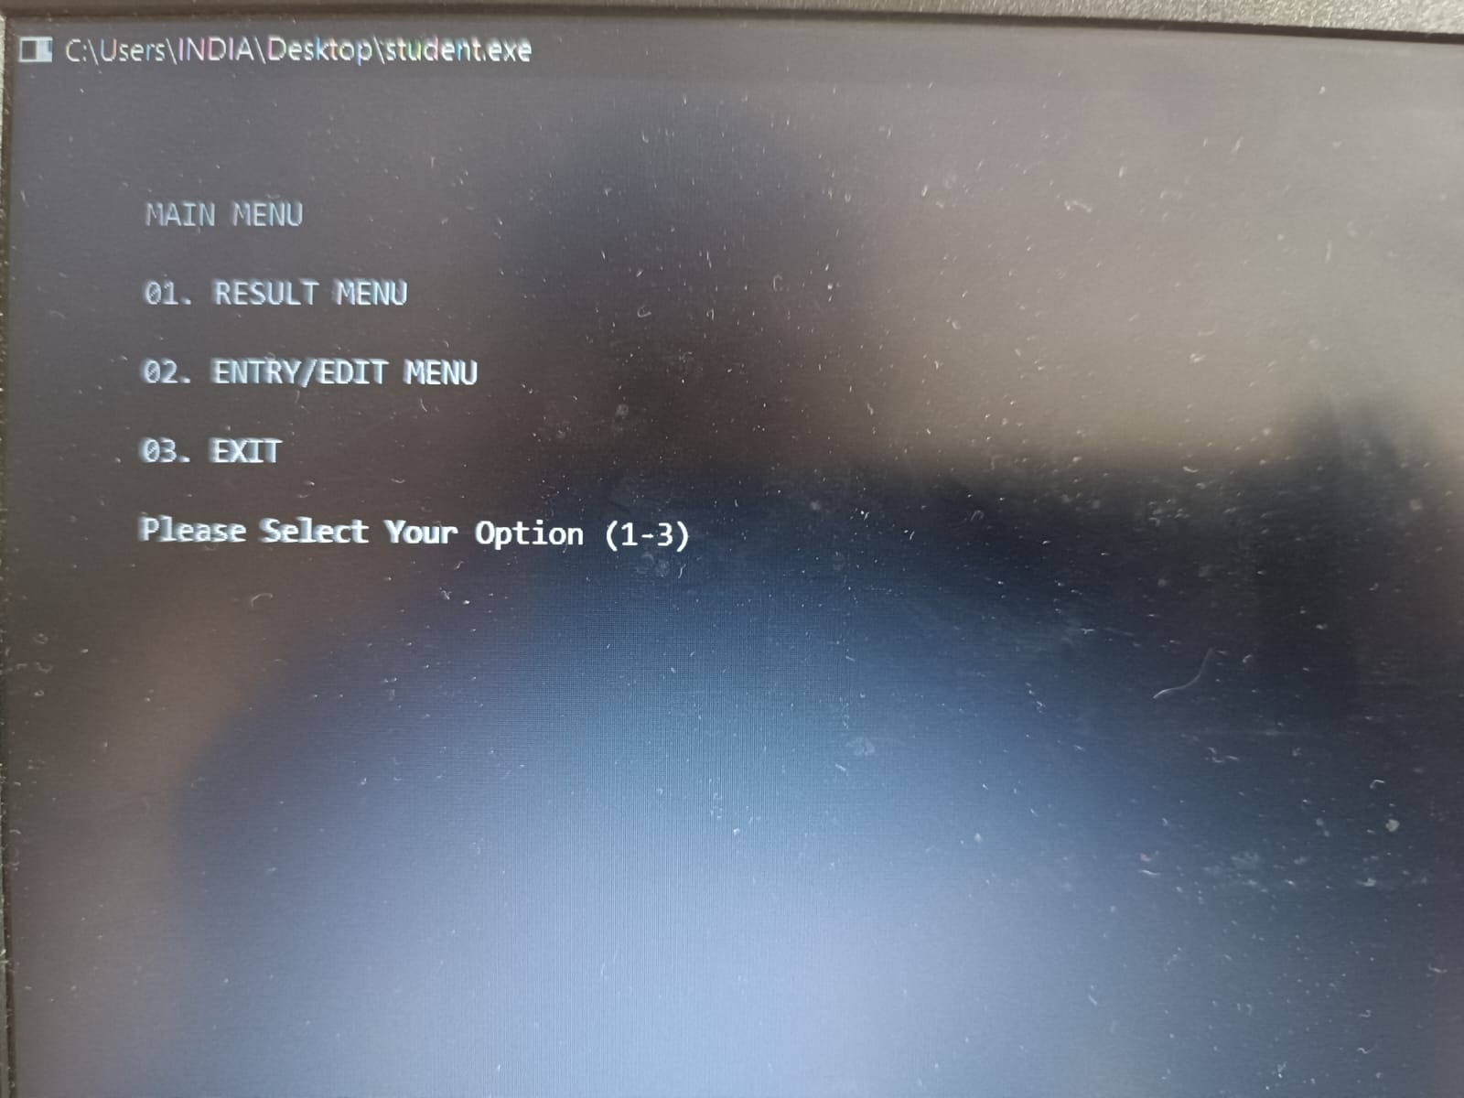

## 

## 

## 

References :

1. <https://www.programmingwithbasics.com/2016/10/c-program-for-student-database.html>

## Thank you!!!